**R Code for Examples in the book**

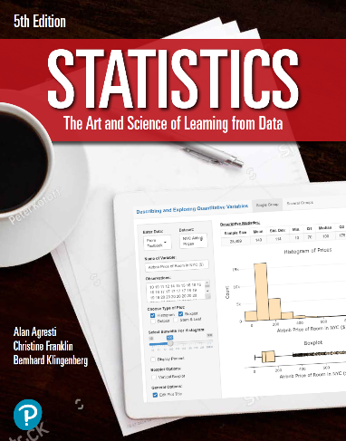

***“Statistics: The Art and Science of Learning from Data”***

**by Agresti, Franklin and Klingenberg, 5th edition**

**Chapter 10**

**Example 10: Bootstrap Distribution of the Difference Between Two Medians**

## Reading in the data

bankLoans <- read.csv(file='https://raw.githubusercontent.com/artofstat/data/master/Chapter10/bank_loan_amounts_term.csv')

## To generate 10,000 bootstrap samples and find each sample’s difference between two means

bootmed_diff <- c() # initializing  
for (i in 1:10000) {  
 bootsample <- bankLoans[sample(seq_len(nrow(bankLoans)),   
 replace = TRUE), ]  
 years5 <- subset(bootsample, term == 5)  
 years3 <- subset(bootsample, term == 3)  
 bootmed_diff[i] <- median(years5$loan) - median(years3$loan)  
}

## To obtain the 95% bootstrap percentile confidence interval for the difference in median loan amounts

quantile(bootmed_diff, c(0.025, 0.975))

## 2.5% 97.5%   
## 500 15100